Chapter 3, Solution 18

Determine the node voltages in the circuit in Fig. 3.67 using nodal analysis.
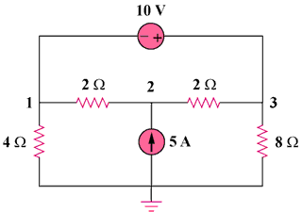

30 V

15 A

Figure 3.67
For Prob. 3.18.

Solution
(b)

15A

v₃

8 Ω

4 Ω

2 Ω

2 Ω

v₂

v₁
– +

30 V

+
v₁
–

+
v₃
–

(a)

At node 2, in Fig. (a), –15 = 0 or –0.5v₁ + v₂ – 0.5v₃ = 15 (1)
At the supernode, = 0 and (v₁/4) – 15 + (v₃/8) = 0 or
2v₁+v₃ = 120 (2)

From Fig. (b), – v₁ – 30 + v₃ = 0 or v₃ = v₁ + 30 (3)

Solving (1) to (3), we obtain,
v₁ = 30 V, v₂ = 60 V = v₃

